NATIONAL UNIVERSITY OF SCIENCES AND TECHNLOGY

(DEPARTMENT OF MECHANICAL AND MANUFACTURING ENGINEERING)

FOP HOME TASK 5

NAME: SYED ALI NAQI

SUBMITTED ON: 28-10-2023

CMS ID: 466889

**TASK 1:**

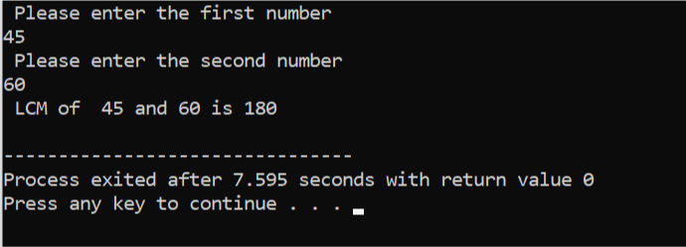#include<iostream>

using namespace std;

int findHCF( int z, int x){

if( x==0){

return z;

}

return findHCF( x,z %x);

}

int findLCM( int z,int x){

int hcf = findHCF(z,x);

int lcm =(z*x)/ hcf;

return lcm;

}

int main() {

int number1 ,number2;

cout<<" Please enter the first number"<<endl;

cin>> number1;

cout<<" Please enter the second number"<<endl;

cin>> number2;

int lcm= findLCM( number1 ,number2);

cout<<" LCM of" <<" "<<number1<<" "<< "and"<<" "<<number2<<" "<<"is"<<" "<<lcm<<endl;

return 0;

}

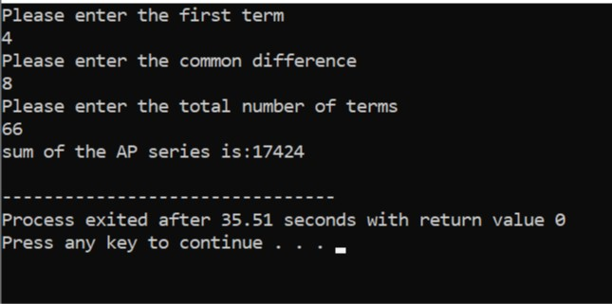**TASK 2:**

#include <iostream>

using namespace std;

int main(){

double FIRSTterm, COMMONdifference;

int numberofTERMS;

cout<<"Please enter the first term"<<endl;

cin>> FIRSTterm;

cout<<"Please enter the common difference"<<endl;

cin>> COMMONdifference;

cout<<"Please enter the total number of terms"<<endl;

cin>>numberofTERMS;

double sum = (numberofTERMS *( 2* FIRSTterm +( numberofTERMS -1)* COMMONdifference)) /2;

cout<<"sum of the AP series is:"<<sum<<endl;

return 0;

}

**TASK 3:**

#include <iostream>

using namespace std ;

int main() {

int P;

cout<<"Please enter the odd number of rows for a diamond:"<<endl;

cin>>P;

if ( P %2==0){

cout<<"Please enter an odd number for a proper diamond pattern"<<endl;

return 1;

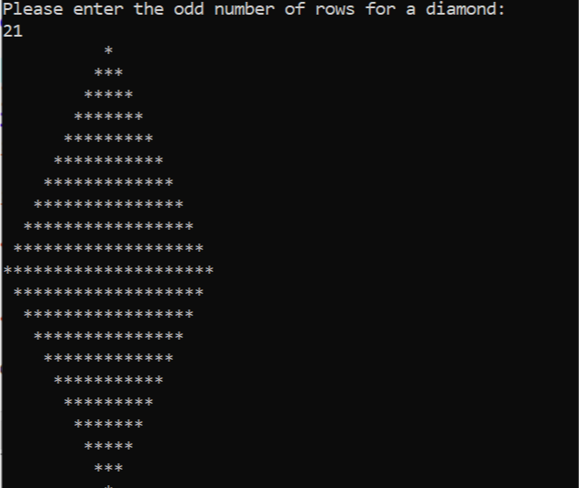 }

for( int i=1; i<=P; i+=2){

for( int j=0; j<(P-i)/2; j++){

cout<<" ";

}

for( int j=0;j<i;j++){

cout<<"*";

}

cout<<endl;

}

for( int i=P-2;i>=1;i-=2){

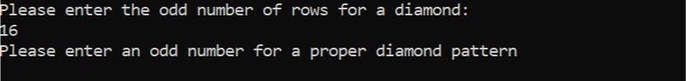 for( int j=0;j<(P-i)/2;j++){

cout<<" ";

}

for( int j=0;j<i;j++){

cout<<"*";

}

cout<<endl;

}

return 0;

}

**TASK4:**

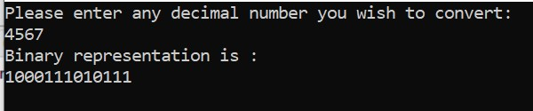#include <iostream>

#include <stack>

using namespace std ;

int main() {

int decimalNUMBER;

cout<<"Please enter any decimal number you wish to convert:"<<endl;

cin>>decimalNUMBER;

if(decimalNUMBER<0){

cout<<"Please enter non-negative decimal number:"<<endl;

return 1;

}

stack<int>BINARYdigits;

if(decimalNUMBER==0){

BINARYdigits.push(0);

}else{

while(decimalNUMBER>0){

BINARYdigits.push(decimalNUMBER%2);

decimalNUMBER/=2;

}

}

cout<<"Binary representation is :"<<endl;

while(!BINARYdigits.empty()){

cout<<BINARYdigits.top();

BINARYdigits.pop();

}

cout<<endl;

return 0;

}